# ITP 359, Summer 2024

# Homework 2 20 points AUTOENCODER

**Denoise CIFAR10 dataset using an autoencoder.**

|  |  |  |  |  |  |  |  |  |  |  |
| --- | --- | --- | --- | --- | --- | --- | --- | --- | --- | --- |
| **airplane** |  |  |  |  |  |  |  |  |  |  |
| **automobile** |  |  |  |  |  |  |  |  |  |  |
| **bird** |  |  |  |  |  |  |  |  |  |  |
| **cat** |  |  |  |  |  |  |  |  |  |  |
| **deer** |  |  |  |  |  |  |  |  |  |  |
| **dog** |  |  |  |  |  |  |  |  |  |  |
| **frog** |  |  |  |  |  |  |  |  |  |  |
| **horse** |  |  |  |  |  |  |  |  |  |  |
| **ship** |  |  |  |  |  |  |  |  |  |  |
| **truck** |  |  |  |  |  |  |  |  |  |  |

This is a dataset of 50,000 32x32 color training images and 10,000 test images, labeled over 10 categories. See more info at the [CIFAR homepage](https://www.cs.toronto.edu/~kriz/cifar.html).

1. Load CIFAR10 dataset can be directly into you Python program using keras. (1)
2. Assign the train and test datasets (1)
3. Visualize 100 images from the train dataset. (2)

1. Scale the images (if necessary) (1)
2. Add noise to the images (for both train and test partitions) (1)
3. Visualize 100 noisy images (from the train partition) (2)

1. Now build a keras convolutional autoencoder to denoise the images. Use at least 4 convolutional layers, 2 maxpooling layers, 2 upscaling layers. (3)
2. Train the model using appropriate hyperparameters (3)
3. Now denoise 50 images (from the test partition). Visualize the noisy and denoised versions of each image. (4)

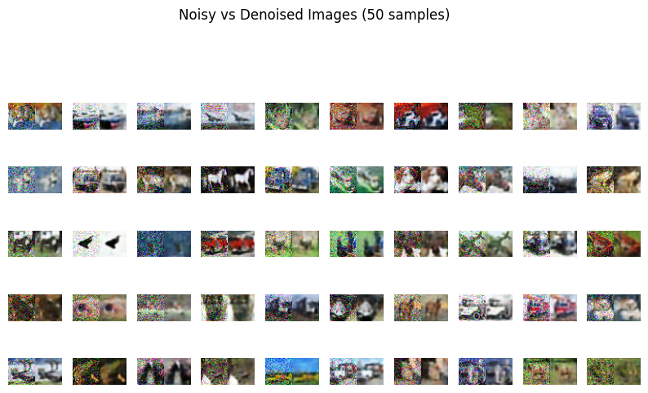

1. Then visualize just three noisy and denoised versions of three images (2)

